REPORT FORMAT OF THE
STATUTORY DAY FOR PUBLICATION IN WEBSITE /IEI NEWS

Name of Centre / Overseas Chapter: | Assam State Centre

Title of Activity: |  |  | World Standards Day 2025
Theme |  | Engaging Youth to Create a Better Urban Future
Date: | 14-10-2025 |  |  | Venue: | IEI, ASC Premises
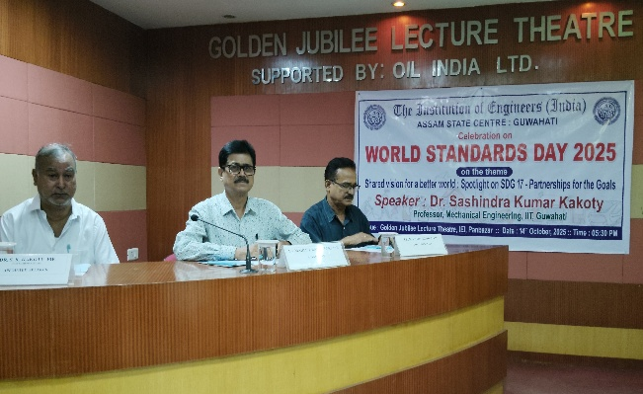  Dignitaries present at the dais | 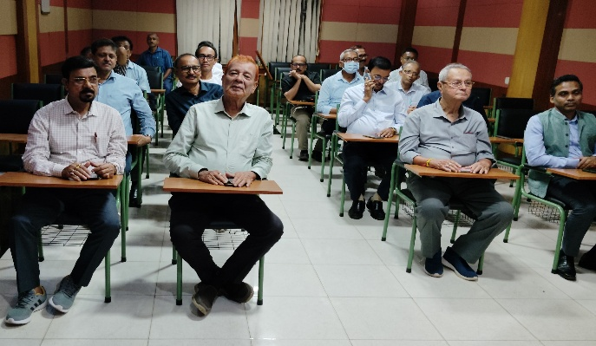  Members present in the meeting
Photos of the Event
Brief Details about the Programme:

The Institution of Engineers (India), Assam State Centre, celebrated the World Standards Day 2025 on 14th October 2025 at its Golden Jubilee Lecture Theatre, Panbazar premises. The meeting presided over by the Chairman of the centre, Er. Mahesh Barkataki FIE and welcome address was given by the Honorary Secretary Er. Monojit Mishra FIE.

Participating as appointed speaker on the theme “Shared vision for a better world : Spotlight on SDG 17-Partnership for the Goals”, Dr. Sashindra Kumar Kakoty, FIE, Prof. Mechanical Engineering Department, IIT Guwahati elaborated through his power point presentation about the significance of World Standards Day in details. Dr. Kakoty has highlighted with examples that the Standards is a cornerstone for extending partnership and it definitely helps in accomplishing SDG-17 to foster partnership.

After that, the Chairman of IEI-ASC summoned up the deliberations of the appointed speaker and expressed his happiness on the presentation. The event came to an end with a formal vote of thanks offered by Er. Suradas Bhattacharjee MIE, Member of IEI, ASC.

